JECRC
JAIPUR
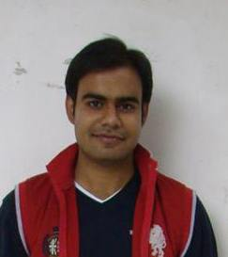
INDIVIDUAL FACULTY DATA SHEET
Name of the faculty member | : | Ashish Sharma
Present Designation | : | ASSISTANT PROFESSOR
Email Id : ashishsharma.ece@jecrc.ac.in
Contact Details : 9680211178
I. Particulars of Educational Qualification: (only completed)

Category | Name of the Degree | Specialization | Year of Passing | Name of the College | Name of the University
UG | B.TECH | ECE | 2008 | Mahrishi Arvind Institute of Engineering and Technology, Jaipur | Rajasthan University
PG | M.TECH | ECE | 2016 | MNIT, Jaipur | MNIT, Jaipur
Ph.D. | -- | -- | -- | -- | --

II. Academic Experience : 7 Years

III. Industrial Experience : --

IV. Title of Ph.D. Thesis : --

V. Awards/Achievements : Topper During M.Tech with AA Grade.

VI. Research/Specialization : Signal Processing, Image Processing

VII. Course Taught : DIGITAL ELECTRONICS, ANALOG ELECTRONICS, EMFT,CIRCUIT

VIII. Refereed International Journal Publication :

IX. International Conference Proceeding : 3

X. Books Written : --

XI. M.Tech Thesis Guide : NIL

XII. PHD Thesis Guide : --

XIII. Professional Body Membership : --

